**ENSE 405 Project report-out & lessons learned**

**Disclaimer**: This template should be used to guide your discussion. The course facilitator asks that you be as open, honest, and professional in your responses as possible. Please know it is OK to agree/disagree with any concept, process, or idea discussed in this course. The knowledge gained from your open, honest, educated, and professional responses may be discussed at a future Engineering Faculty and/or “Canadian Engineering Education Association (CEEA)” event.

**Project name**

ConsciousCart by Michael Osachoff

**Project sponsor & course facilitator**

Dr. Tim Maciag (ENSE 405 professor)

**Business need/opportunity**

As part of the United Nation’s 17 Sustainable Goals, individual consumers are asked to reduce their waste, and be thoughtful of what they buy and to choose sustainable options whenever possible. This includes reducing, reusing, and recycling waste created by food whenever possible, and to utilize composting and proper disposal of organic waste whenever possible. There lacks an easy-to-use application for tracking and reducing a home cook’s waste based upon the recipes that they create.

**Reflections on project planning (3-5 pages)**

* State and discuss the United Nation’s (UN) Sustainable Development Goals (SDGs) selected and your “why” for selecting the one(s) you did

For my project ConsciousCart, I selected 2 of the 17 United Nation’s Sustainable Development Goals. The first is SDG 12: Responsible Consumption and Production, and the second is SDG 13: Climate Action. I chose these goals because in my opinion as someone who has cooked for themselves for many years, they seemed to be the most impacted from the application I was planning to create / have created. Although my application may not have a substantial impact on responsible production as home cooks are not making products from raw ingredients, I believe home cooks can make a big difference in their responsible consumption practices. Based on the ingredients being incorporated into their recipes and dishes, a home cook can minimize the waste that they create by choosing the environmentally most responsible products. This could allow an individual to do their part in contributing to SDG 12. For SDG 13 of Climate Action, a home cook can choose the most responsible packaging to reduce their carbon impact. Packagings that are reusable, recyclable, or compostable can reduce both an individual and global impact as they reduce the need for new packaging to be created. For instance, if a home cook purchases a product with a paper-based packaging that can be recycled into cardboard after use, then they will have a reduced carbon impact compared to a hard plastic or plastic wrap packaging that may end up in a landfill based on a given jurisdiction’s recycling practices. Although not listed in project planning documents, and upon reflection of my chosen SDGs in the end-point exam, I may have more of an impact on SDGs 14 and 15 instead of 13. These are, of course, Life Below Water and Life on Land, respectively. This is because my application has more focus on packaging waste that would affect the life in the environment around us more than the carbon and climate impact of our atmosphere.

* Discuss key findings from your community research and understanding/requirements gathering (Community characteristics and technology configuration inventory)
  + Discuss your professional opinion of the processes and documentation used in this course for project planning. Did they help/hinder and how?

Based on my Community characteristics documentation, I believe the home cook community that I attempted to target was mainly within a self-designing state in their life-cycle as a large number of nations and individuals are familiar with the United Nation’s SDGs and their own impact on the environment, but they lack solid tools to allow an individual to make an impact. They appear to be a very diverse community as anybody of any age, orientation, country of origin, or level of skill could be a home cook that can create meals for themselves. Due to the asynchronous nature of the activity, home cooks are mostly focused on content and individual participation orientations as they look for new recipes to cook for themselves or perhaps an audience.

I think the processes and documentation used in this course for project planning can be useful for software engineers to gain knowledge on their community of practice, but it lacks significant value for those that are very familiar or actively participate in the community that they are attempting to target. While this may be useful in providing experience for a software engineer so that they may be more effective in applying it in industry, the documentation process can be quite tedious in providing information that may have no application when developing.

* State selected north star & carryover customers. Why are these customers important to your project’s golden circle (why, how, what)?

My north star customer is home cooks looking to reduce their product-based waste in the kitchen. My carryover customers may include food or environmental bloggers who are interested in writing about or using products that can reduce their environmental impact. In terms of my “why”, the core purpose is to empower home cooks to reduce waste and make environmentally responsible choices in their cooking habits, and carryover customers can improve upon this by expanding the overall impact of my application. For the “how”, the application will be tailored to meet the needs of the north star customers, home cooks, and once that is satisfactory, the carryover customers may be already impacted, or may require additional design and development to ensure their needs are met. Finally for the “what”, my application will allow the home cooks to create recipes and view their waste reduction scoring and history tracking, while the carryover customers may learn or utilize information that was destined for home cooks but may work for the own personal uses.

* Summarize assumptions made and constraints uncovered, re: drafting an emerging picture

The existing technology inventory for home cooks looking to incorporate the functionality of my application within their work is lackluster. Often tending to pigeonhole itself into the content, individual participation, and possibly the access to expertise orientations. It also appears to lack a form of community that has consistent interactions on the platform between users, so it doesn’t have a noticeable impact on the meetings and relationship orientations. Furthermore, there is likely a wide range of skills based on the people that could be within the community. The people involved in the community could include a wide range of cultures and ages that may have different technological skills. It could cause conflict in the desire of the interface designs.

* Discuss initial & the evolution of your technology stack selection, drafted prototypes, and initial Minimum Viable Products (MVPs)

Initially, my planned technology stack was a MERN stack. In order, this would include the MongoDB database for data storage, Express for assisting the RESTful API in my backend, React for displaying the required information to the user in a graphical interface on the frontend, and finally Node for containing and servicing the business logic on the backend of my application. After beginning my project however, I transitioned from using the React framework on my frontend to the Flutter framework, as I envisioned it would have more support in creating a mobile application than the React framework which I have had more practice in using for desktop purposes. Ironically, by the end of the project I somewhat regretted this decision as Flutter created a number of grievances in its design and implementation that may have been more easily resolved or impossible to be caused if I had used my initial choice of the React framework. My drafted low-fidelity prototypes were directly applied in the design that I created for my frontend interface, with a nearly identical appearance. My initial Minimum Viable Products (MVPs) stayed constant throughout most of the development cycle, but had some packages removed as some of them were simply not required. For instance, deploying the application to a public API that was properly set up and serviced, or full integration with the Open Food Facts API to gain additional real-time knowledge on new products and packaging that would be useful within my application. These packages were not developed as they simply seemed out of scope for the project within this term and would provide no value in what would be represented in my final demonstration when closing the project. But on the other hand, there were concepts and designs that were brought into the work packages and MVPs that were not initially designed because they were thought of after initial designs or given as feedback , but would provide a more delightful experience for the user. For example, this includes the link on the history page to the Open Food Facts website to implore the user to commit data to the organization that would be provided in the application, and the use of background images on the three main tabs’ landing pages to create a more visually appealing interface.

* Provide images/screenshots where appropriate/needed

**Reflections on project results (4-5 pages)**

* Discuss what you created. Provide key images/screenshots illustrating core functionality
  + Review your initial “Planning and initialization” video created for the first deliverable. How close did you come to realizing the solution/product you initially envisioned?
  + Summarize software design activities and findings. Ensure you discuss how you/your team either linked or envision links to design ideas back to topics discussed in class lectures

My product is a mobile-based application created for home cooks to track and ideally reduce the waste created by the recipes that they create based on the products that they have incorporated within them. It is split into three main sections or pages that a home cook (user) can interact with: recipe creation, recipe history and breakdown, and user profile. The recipe creation page allows the home cook to name their recipe and search for products that they want to add to this recipe. Based on the chosen products and the packaging that they have, the recipe is assigned a “waste score” to provide it with a metric on how environmentally friendly the product(s) and recipe are as a whole. An example of the recipe creation page can be seen below in Figure 1:

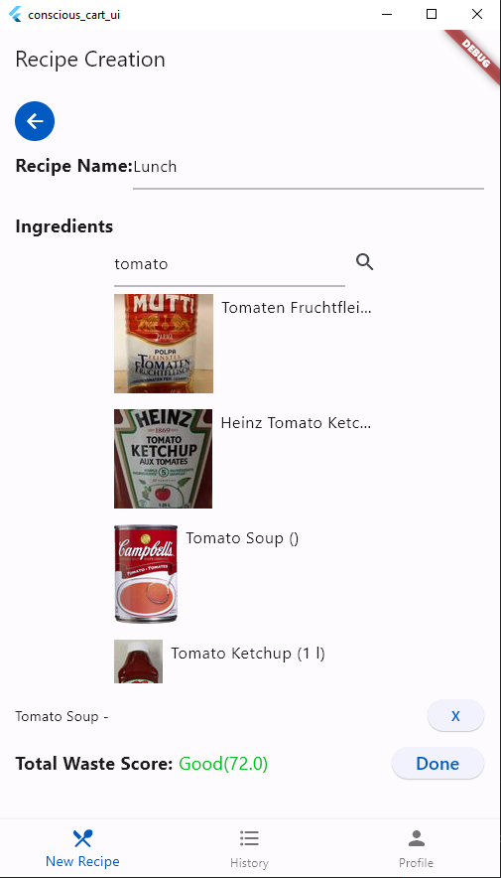

Figure 1: Recipe Creation

The recipe history and breakdown page can empower the home cook to see what impacts their recipes have on the environment. This is done through two states of a list view to show all recipes that a home cook has already cooked, and the breakdown view where a single recipe is shown with its name, date created, and each of the products or ingredients that have been incorporated. Each product shows a breakdown of its packaging and what level of impact that has on the environment (low, medium, or high). Examples of the list view and recipe breakdown are shown in Figures 2 and 3 below:

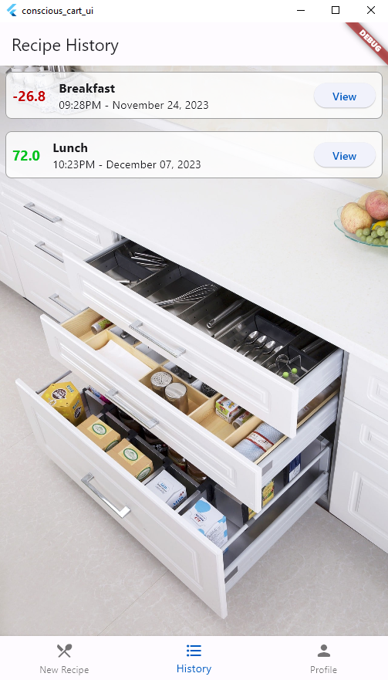

Figure 2: History Page List View

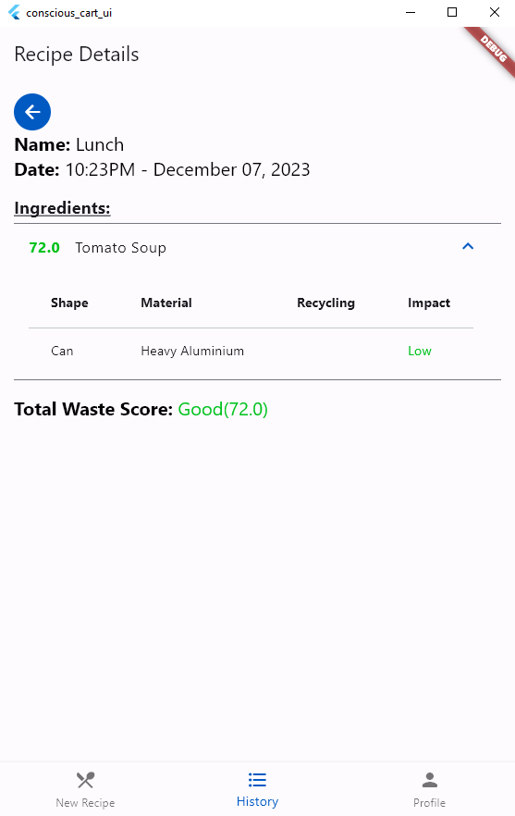

Figure 3: History Page Recipe Breakdown View

The final section of the user profile page is a very simple component of the application. It simply allows the user to store some personal information such as their name, a username, an email, and a password. This information has no impact on any business logic since this is a proof of concept, but perhaps this page could be expanded upon in future iterations. It could be an explore/community page that home cooks could utilize to learn more recipes and their impacts based on what other home cooks within their community create. But in its current application, it simply acts as a placeholder for this proof of concept application. The view and edit states of the profile page are shown in Figures 4 and 5 below:

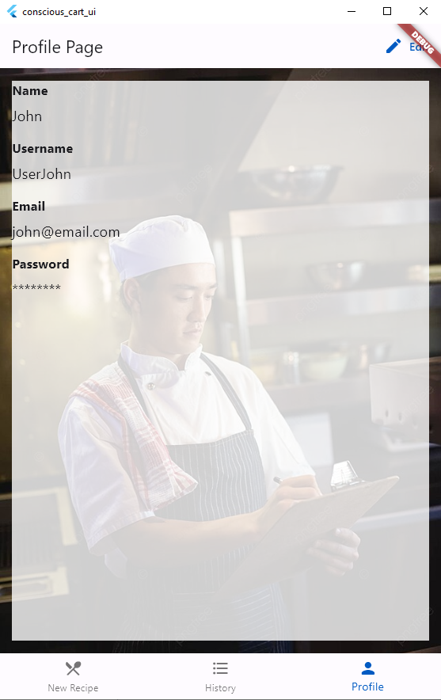

Figure 4: Profile Page View

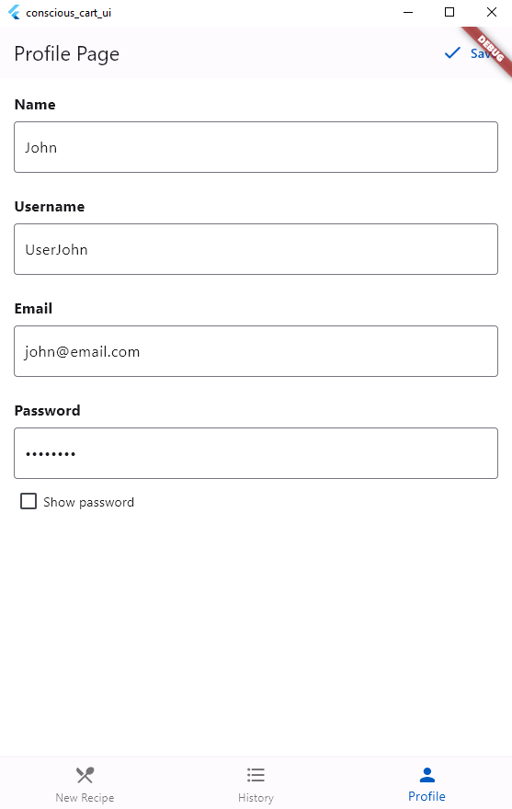

Figure 5: Profile Page Edit

Upon reviewing my “Planning and initialization” video created for the first deliverable, I think I got a majority of the main functionality in my application, but I was missing some of the nice-to-have pieces that I think could have had a very positive user experience if implemented. This includes a full account creation of a signup, login, password reset, and customization. These aspects were not developed as it did not provide direct value in the core aspects of recipe creation and tracking. But I was content with the fact that a majority of these core functions of searching for products, adding and removing them from a recipe, and then being able to view their impacts was implemented for the user to experience.

Throughout my project, I attempted to apply some of the class concepts within my design. The first concept that I tried to incorporate was to use Free & Open Source software throughout my entire application, and this comes from our 10th lecture of ‘“Creativity is Queen” When Everyone is a Media Outlet’. This meant having my GitHub repository open to the public, and using Free & Open Source components throughout my entire technology stack. My backend was using a download from the Open Food Facts public database, and the MEFN (MongoDb, Express, Flutter, Node) stack that I utilize are all Free & Open Source for anybody to use. From this, any developer in the future could utilize the same technology and even the same code that I used to create a similar or even improved product. The second concept that I tried to incorporate was the idea of gamification. A score or a value of sorts for the user based on each recipe they create, could allow them to see a scoreboard with each of their top scores and gauge how they may have improved by reducing their individual waste during their time of using the application. Expanding upon this, I also included the opportunity for home cooks to contribute information themselves where it was missing in the Open Food Facts data, and this was done through a link on my history page to the Open Food Facts website.

* Summarize how you felt about this project (likes/dislikes), from your experiences with the technology stack selected, translating prototypes into real solutions, and the creation/realization of your MVPs
  + Summarize what went well during the project
  + Summarize what not went well during the project
  + What would you do the same on future projects?
  + What would you do differently on future projects?

I enjoyed selecting my only technology stack for this project. While many students chose a similar stack of something similar to MERN, it was enjoyable to have flexibility in what software I could use to make my application come to life. The use of a MEFN stack was overall good, but as previously discussed, the use of Flutter on my frontend became quite frustrating by the end of the project as writing readable and clean code that creates an interface that you desire can be quite difficult without good experience. I don’t have much to speak about the process of translating prototypes into real solutions as my low-fidelity diagrams were almost directly translated into the frontend of my application. The creation and realization of MVPs was a rather simple process as I attempted to determine all of the necessary features to create my application, and then furthermore implement as per the basic design that I had envisioned.

In my mind, what went well with the project was being able to retrieve Free and Open Source data, and basic recipe creation and viewing features. Things that did not go too well included the search feature for products not being very “smart” in providing the user with what should be the requested product, the search does not have interaction with the Open Food Facts database, and a few small issues such as render overflows or images not loading on Linux.

I would likely use the same technology stack in the future, but swap out Flutter with a more robust framework that I have more experience with such as React. This would resolve the grievances that I had with Flutter in creating my frontend. I would also look for a better source of food products and packaging than Open Food Facts as it has good data upfront, but may lack a number of products or their descriptions that I may require in order to create my solution.

* Discuss opportunities and design ideas for future work

Although I do not intend to work on the project in any time in the near future, there are definitely aspects of the solution that could be improved on to create a better user and developer experience. Firstly, either choose a better source of data for food products or include a proper implementation of the Open Food Facts API to allow for a more diverse range of products than simply Canadian products, and remove the products from the local MongoDB database. Secondly, improve the search feature for the recipe creation tab to sort and filter products closer to what the user likely intends to search for, with a slight bias on popularity of the products. For instance, display a common brand of soup such as CampBell’s first in the list instead of a local brand that the majority of the population has not purchased or even seen before. Thirdly, incorporate a number of quality-of-life functionalities to the recipe and history page to create a better user experience. This includes ingredient serving sizes and servings used, remove the ability to add a product multiple times, sorting and filtering on the history page, and popups or descriptions of some sort to better describe the waste scores attached to an ingredient and recipe. Finally, look into what may be required to ensure the application can operate on the variety of operating systems and devices that may be used, such as Android and Iphone, Windows, Mac, and Linux.

**General reflections on the class & project experience (3-5 pages)**

* Before taking ENSE 405, were you aware of the UN SDGs?
  + Yes/No – Please elaborate

Before ENSE 405, I was not aware of the UN SDGs specifically, but I was familiar with a number of the efforts that the United Nations was attempting to undertake that fall under the umbrella of the SDGs. This includes concepts such as reducing poverty, global hunger and lack of clean water, clean energy and environment, etc.

* Typically, before taking this class, when you engineered software solutions, were you concerned with areas encompassing the UN SDGs?
  + Yes/No
    - If yes, provide some past examples and explain
    - If no, do you have examples of past engineered works that you (co)created that could address one or more of the UN SDGs

Since I was not familiar with the UN SDGs and their goals as a whole, I often did not attempt to actively address the areas encompassing them. My previous work of Project P.A.T. (Physical Activity Tracker) from ENSE 374 could have had an impact on SDG 3 - Good Health and Well Being. The goal of this project was to provide a better web-based tool to track physical activities and assist people in reaching their goals with tracking, as well as finding things that others are doing with sharing and/or suggestions given to them by the application. This would directly have an impact on SDG 3 as individuals attempt to improve their health and well being by tracking and ideally improving their physical activity.

* Did learning about the UN SDG(s) help you understand better your role and responsibility as an engineer to society?
  + Yes/Neutral/No – Please elaborate

The UN SDG(s) did provide me with an opportunity to better understand what will be required of me was a software engineer as all of the SDG(s) provide areas that should be improved and focused on by society and as software engineers we have the ability to make a substantial change in the world based on the applications that we create.

* What was your experience(s) in engineering your specific software solution to address the UN SDG(s) selected?

It was a very interesting experience because I have never attempted to engineer a software solution that would be targeted towards simply attempting to help the world instead of trying to make a product for a business looking to turn a profit. I think it opened my view for creating products that are simply made to help people and I may look to work on more projects like this in the future if I enjoy the cause that a project is fighting for.

* As a future engineer, what are your thoughts on the UN SDGs as a whole? Do you think they can help or hinder our work as software engineers?

I think the UN SDGs as a whole are a very positive, yet possibly restraining, set of concepts to think about when creating applications. In my opinion, I believe it can open a number of doors for companies to strive towards in the product(s) that they are attempting to create, but it may prevent other companies from creating something desirable. By this, I mean that some companies may focus on targeting these SDGs and making them more prevalent for the end user to be aware of, but this may turn away customers looking to use the application that don’t find such incorporations enjoyable.

* Should we use the UN SDGs to guide our work or is our work dependent on customer requests, regardless of the UN SDGs?

I think we should encourage our customers to allow us to incorporate the fundamentals of the UN SDGs into our work, but the decision to do so should be made by the customer themselves. If we simply follow the UN SDGs to a tee, it may cause us to create a product for our customer that they do not want and waste both development time and financial resources in doing so.

* Will you use your understanding of the UN SDGs in engineering solutions in the future?
  + Yes/No/Maybe – Please elaborate

Since I have no immediate application that can viably implement my understanding of the UN SDGs, it is hard to say if I will use my understanding or not in the future. Based on what I have learned about what the United Nations is attempting to achieve, and the vast number of nations that are committed to completing these goals by a specific date, I think I may have a number of opportunities in the future to apply my learnings.

* Will your experience learning about the UN SDGs inform your career path decisions in the future?
  + Yes/No/Maybe – Please elaborate

I don’t have any specific career paths or notable ambitions about the areas in the software engineering industry that I want to work in after the completion of my degree, so it is hard to say if my learnings about the UN SDGs will have an impact on it. After working for a few years with a bit of experience under my belt in the field that I choose, I may look to transition to a company or another branch of the industry that is focused on fulfilling one or more of the SDGs.

* Provide any other comments on the project

By the end of this term, I personally have a mild distaste for this project. Although there are positive factors that students are able to choose their own technology stack, define their project scopes, and determine their own MVPs, I believe there is too much content within the course to be able to deliver a viable product for the project by the end of the term. Lecture content and blogs take on average 3-4 hours per week, students may take 1-2 hours to prepare scrum content, and on top of that students are also expected to spend roughly 4-5 hours to prepare all project documentation and planning. With all of that said, there still must be time devoted to project design and development. This includes setting up local environments, data research gathering and implementation, the interface design and development, and a backend with necessary business logic. A number of students that I have spoken to about the class share a common opinion with myself that there is simply too much content required to meet the requirements set out by the project and class as a whole. Often I have heard that students are spending more time on the project required for this class than their project for their Capstone, and not to mention that students are often taking a full load of classes, so they may have another four classes of work as well. Respectfully, I believe the course has an appropriate workload for students that are only taking this course, but it appears to vastly outweigh the time required for a course when compared to the other available courses that software engineers are likely to take in their third or fourth year of their degree, including the Capstone preparation course (ENSE 400). In my own opinion, I think the course would fit better with a full design of the application that the software engineer could intend to implement, but to stop before the development process starts. Making the proof of concept product requires a large time sink for this course and I believe that prevents a notable amount of students from having the desire to continue the project upon completion of the course.